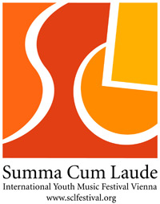

Music repertoire for the Summa Cum Laude Festival

Official name of the ensemble: XAVIER COLLEGE STRING ORCHESTRA

Competition/ Celebration program (total duration: Competition Choirs 15-20 Min., Competition Orchestras and Bands 20-25 Min., Celebration (all categories) 20 Min.).

Composer | Dates of birth/death | Work  Please indicate, which pieces require a piano (p), a keyboard (k) or an organ (o)! | Opus | Duration
W.A.Mozart | 1756 to 1791 | Divertimento No. 2 in B flat, 2nd and 3rd movts | K137 | 6 min
Eve Duncan (Australian) | 1956 | Mirrabooka Morning |  | 4 min or 5 mins with didjeridu
A. Vivaldi | 1678 to 1741 | Concerto Grosso in D RV 549, 1st. movt.( 4 Violins ) | Opus 3 No.1 | 3 min
L. Janacek | 1854 to 1928 | Suite for Strings, 5th and 6th movts. |  | 3.30 plus 3.50 mins.
 |  |  | Total: | 20.20minsor  21.20mins

Workshop pieces (orchestras only)

Composer | Work | Opus | Duration

Additional concerts program (total duration approximately 45-60 minutes)

Composer | Dates of birth/death | Work  Please indicate, which pieces require a piano (p), a keyboard (k) or an organ (o)! | Opus | Duration
 |  |  | Total:

Please forward to the artistic director’s office:

agentur legato
Mr. Juergen Partaj
Seilerstaette 5
A- 1010 Vienna/ Austria
Email: juergen.partaj@sclfestival.org

