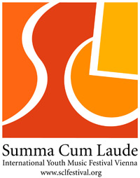

Music repertoire for the Summa Cum Laude Festival

Official name of the ensemble: XAVIER COLLEGE CHAMBER CHOIR

Competition/ Celebration program (total duration: Competition Choirs 15-20 Min., Competition Orchestras and Bands 20-25 Min., Celebration (all categories) 20 Min.).

Composer | Dates of birth/death | Work  Please indicate, which pieces require a piano (p), a keyboard (k) or an organ (o)! | Opus | Duration
Herwig Reiter | born 1941 | O du lieber Augustin III (p) |  | 1min 20 sec
Mai |  | Rauberlied (p) |  | 2min 20sec
Stephen Leek | born 1959 | Araluen Summer (p) |  | 3min
Stephen Leek | born 1959 | Drovers (p) |  | 2min 30sec
Jonathan Larson (arr. Richard O’Shaughnessy) | born 1960 died 1996 | Seasons of Love (p) |  | 3min
Freddie Mercury (arr. Anne Raugh & Deke Sharon) | born 1946 died 1991 | Crazy Little Thing Called Love (p) |  | 3min
 |  |  | Total: | 15mins  10sec.

Workshop pieces (orchestras only)

Composer | Work | Opus | Duration

Additional concerts program (total duration approximately 45-60 minutes)

Composer | Dates of birth/death | Work  Please indicate, which pieces require a piano (p), a keyboard (k) or an organ (o)! | Opus | Duration
 |  |  | Total:

Please forward to the artistic director’s office:

agentur legato
Mr. Juergen Partaj
Seilerstaette 5
A- 1010 Vienna/ Austria
Email: juergen.partaj@sclfestival.org

