**Richard O’Shaughnessy conductor of the Xavier College String Orchestra**

Richard completed his Bachelor of Music in 1994, specialising in singing and music education. He has performed with the Victorian State Opera and Australian Opera in several productions including La Boheme, Aida and Lakme.

He has taught music to all ages and has a passion for unaccompanied singing and Musical Theatre. In the school setting Richard has directed many musicals from Gilbert and Sullivan's The Mikado to Sondheim's Sweeney Todd. Richard has an interest in composing and has written numerous string and vocal arrangements for the students under his care. Richard is currently the Co-ordinator of Voice at Xavier College, where he has been teaching music, theory and voice for the past decade.

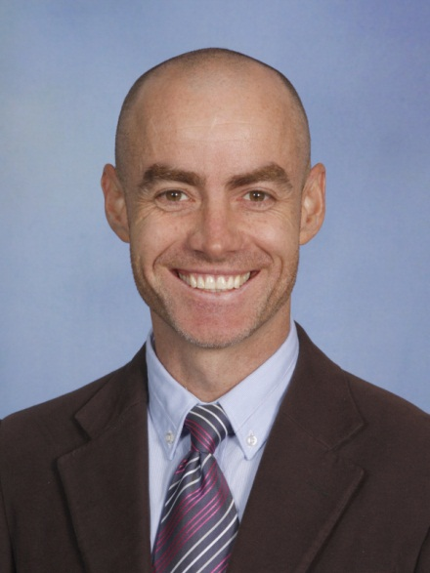 Richard O’Shaughnessy

**Andrew Schellhorn conductor of the Xavier College String Orchestra**

After studying violin at the Victoria College of the Arts, Andrew accepted a scholarship to study in Koln with Helfried Fister. Through his time with Helfried Fister, Andrew gained a realisation that teaching was his main passion. He returned to Australia to work especially with children.  
He founded two youth orchestras which toured Europe and performed in concerts and master- classes around Australia. Many of his students have gone on to become teachers, performers and competition winners in Australia and overseas.  
Presently Andrew is the Head of Strings at Xavier College, where he works with eleven string teachers to present instrumental and ensemble programmes to over 300 students of Double Bass, Cello, Viola and Violin.  
He is an active member of the Australian String Teachers Association which held its national conference at Xavier College last year.

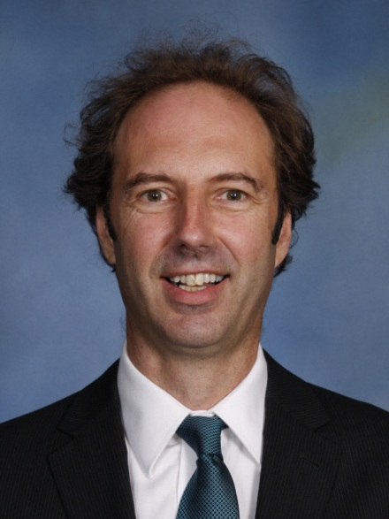 Andrew Schellhorn